SELECT TABLESPACE_NAME FROM USER_TABLESPACES;

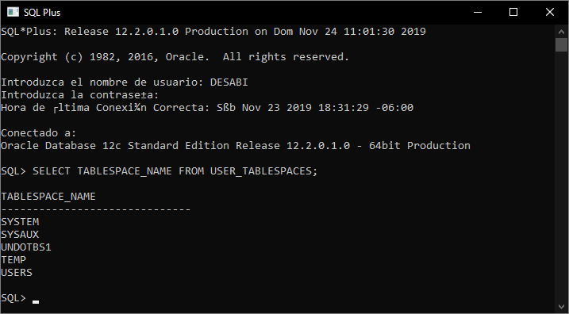

SELECT TABLESPACE_NAME, FILE_NAME FROM DBA_DATA_FILES;

